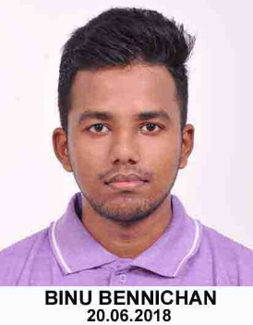
RESUME

BINU BENNICHAN
Email : binubhai1234@gmail.com
Mobile : +91-9597133296
Career Objective
To hold a good position and be a part of an organization where I can fully utilize my skills and make a significant contribution to the success of the organization at the mutual benefit.
My Self
I am a person with positive attitude, self-confidence, quick learner, who works whole-heartedly in each and every activity taken up and thereby achieves excellence. I consider myself to be a work-oriented person having assets of intellectual knowledge, sociability and a flavor to do work in any atmosphere.
Education
Degree | Branch | Year of Passing | College/School | University/Board | Percentage / CGPA of Marks
Bachelor of Technology | Mechanical Engineering | 2018 | Karunya Institute of Technology & Sciences Coimbatore | Karunya University Coimbatore | 7.40
HSC – XII | - | 2014 | Kendriya Vidyalaya No.1, Itanagar | Central Board of Secondary Education | 80.3%
SSLC – X | - | 2012 | Kendriya Vidyalaya No.1, Itanagar | Central Board of Secondary Education | 7.8
Project - Details
Project Title: Design, Analysis and Development of Hybrid Power Generation unit using Impact load. (5Months)
Project Description | The main idea of this project is to develop much cleaner and cost-effective power generation method, which in turns helps to bring down use of non-renewable fuels. Placing the prototype in public areas such as footpaths, staircase etc. to tap the energy from the impact load generated by the continuous public movement over it. By this prototype power developed by human beings while walking is utilized efficiently. Here the mechanism used for developing energy is a hybrid combination of Rack and Pinion, Hydraulic and Piezoelectric system.
Personal Skills
- I have good communication skill and exceptional creative idea.
- Strives for perfection in every work.
- Good in team work and team leading.
- Good team player and Keen learner.
Training
- Undergone industrial training at AutoKast Ltd., Cherthala (20 days).
Technical Skills
- ANSYS**
- Creo (Basics)
- AutoCAD (Basics)
Achievements
- Achieved Grade B1 in Cambridge English Language Assessment.
- Participated in Mindkraft, a national level techno-management fest held at Karunya University.
- Achieved Second prize in Lathe IT.
Seminars
- Attended seminar on “You Can Invent” organised by Entrepreneur Development cell.
- Attended one-day seminar on Fuel cell and Hybrid vehicle Technology.
- Attended a workshop on Geometrical Dimensioning and Tolerancing.
Leisure Interest
- Playing Cricket.
- Listening Music
- Painting
Personal Information
Personal Information
Full Name | Binu Bennichan
Date of Birth | 02-October-1996
Father Name | K.C Bennichan
Permanent Address | Umbukadu House, Thalayolaparambu P.O, Kottayam
Phone | +91-9074911631
Languages Known | Malayalam(R,S),English(R,W,S) & Hindi(R,W,S)
Declaration
I am keen to continue my career and prepared to work hard in order to achieve my organization objectives and I hereby declare that the information furnished above is true to the best of my knowledge.
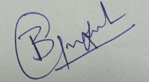
PLACE : THALAYOLAPARAMBU
DATE : [BINU BENNICHAN]

